Worked with Lam to confirm the schematic of power circuit (doesn’t have LDO voltage regulator yet)

Met up firday evening Lam worked on the schematic, I worked on implementing the chagnes from Shivam emailed earlier in the day:
- Missing power label
- Adding C to 32Khz OSC
- Double check ferrite bead spec recomendation
- Confusion over using raspberry pi ( raspberry pi does not connect or get power from our PCB)
- Diodes 2 & 3 should be before the boost or buck not after
Also peer feedback.
Mainly feedback on having more detail on some slides like electical diagram, explaning stuff better. & some slides dragged on too long.
Feedback for PCB: mainly crowded & unclear
Also lots of confusion on separating the raspberry pi & PCB

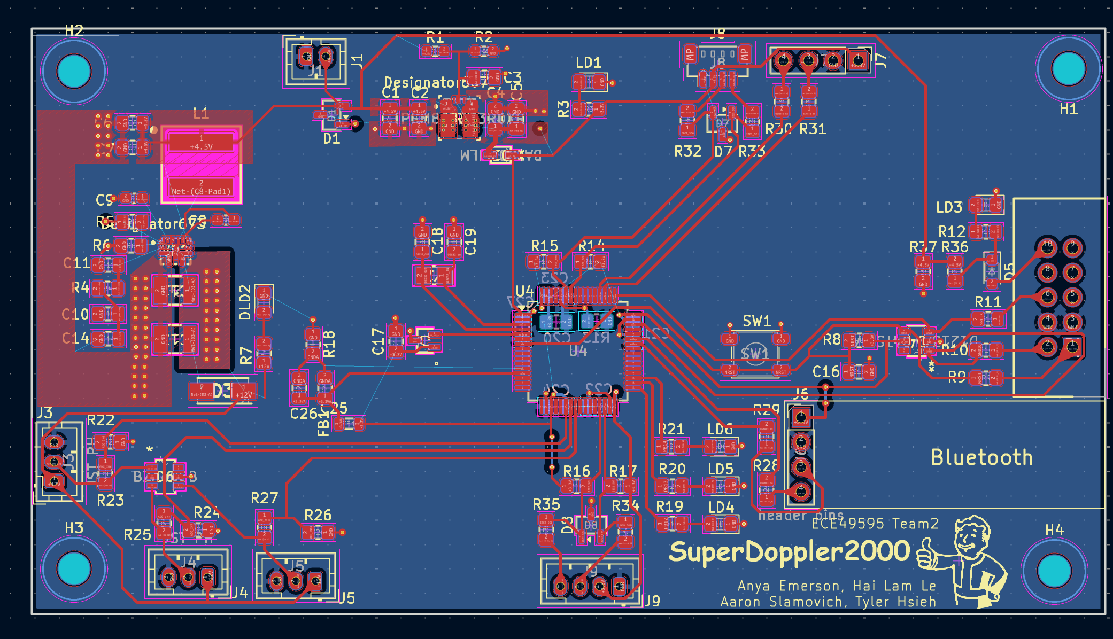
Layout as of Fri evenng
Once analog ground handled & double check boost layout & power vias, will submit for review.

